2gather PLATFORM registration guidelines – FAQs
http://rcel.enl.uoa.gr/togather/
- To enroll: follow steps 1-4.
- Have a look at the General and Group Announcements.
- Then join the forum.
- How can I sign up as a new member?
The best way is to go to the top right corner of the page with the green tiles. Click “Sign Up” on the “Hello Guest” tile.
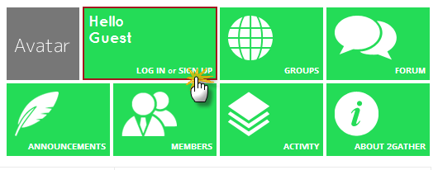
From there you should fill in the appropriate fields. Finally, click “Complete Sign Up”.
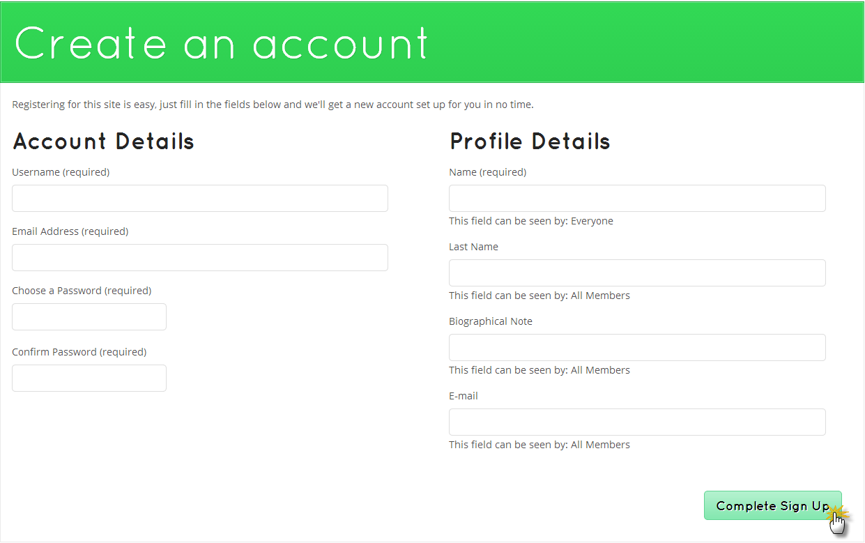
After you sign up, you will receive an activation email. Follow the instructions.

- How can I log in?
Go to the top right corner of the page with the green tiles. Click “Log In” on the “Hello Guest” tile.
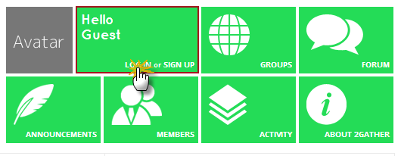
Or you can directly use the Log In box in the lower right corner of the page. Fill in your username and password and click “Log In”.
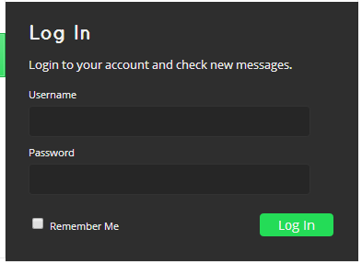

- How can I join the appropriate ELTeachers Group?
Go to the top right corner of the page with the green tiles. Click the “Groups” tile.
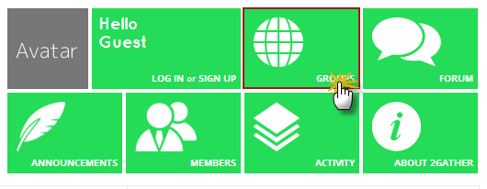
From there you will see a list of groups below. Click the appropriate ELTeachers Group.
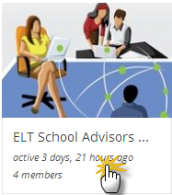
Underneath the name of the group click “Request Membership”.
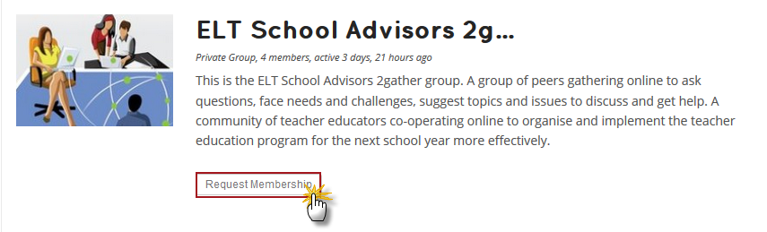
And then click “Send Request”:
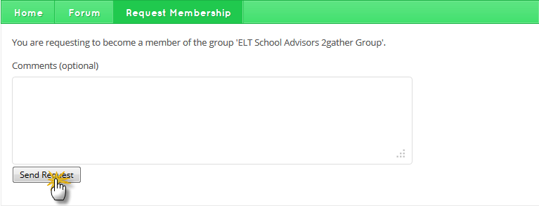

- How can I edit/update my profile/Avatar?
Go to the top right corner of the page where the green “HELLO” tile is. Click your username.
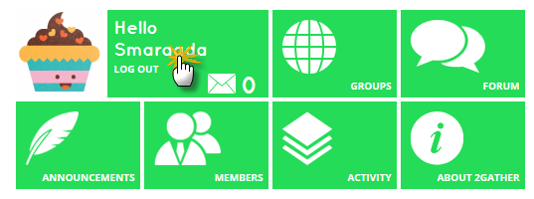
From the menu that appears underneath your username click “profile”.

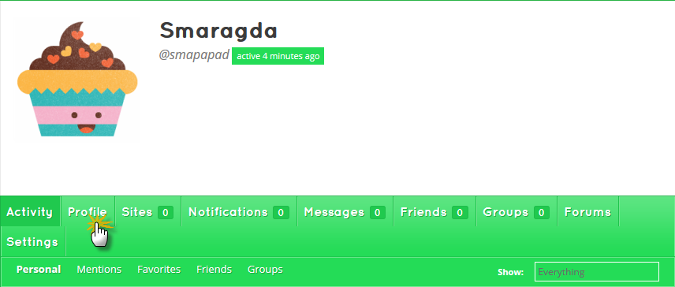

Then click “Edit” to make the desired modifications.
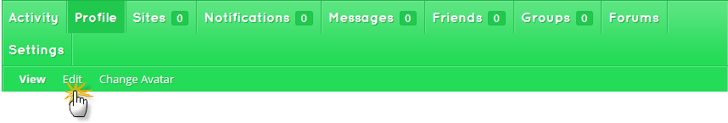
You can also upload your picture/Avatar by clicking “Change Avatar”.
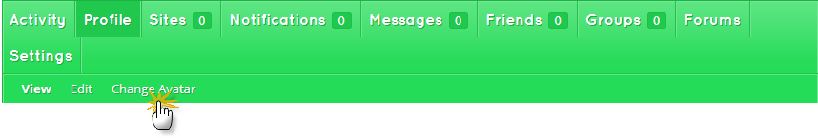

- What is a general announcement? Who can write one?
It is an announcement that can be seen even by non-registered users. It can only be written by the site administrator.
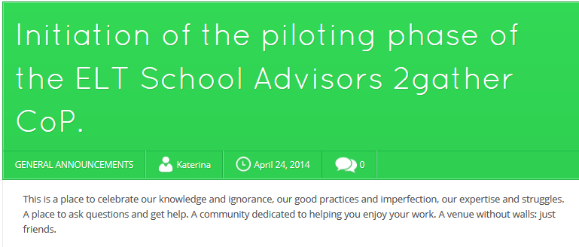

- What is a group announcement? Who is it read by?
It is an announcement that can only be seen by group-registered users. It can only be written by the group’s moderator.
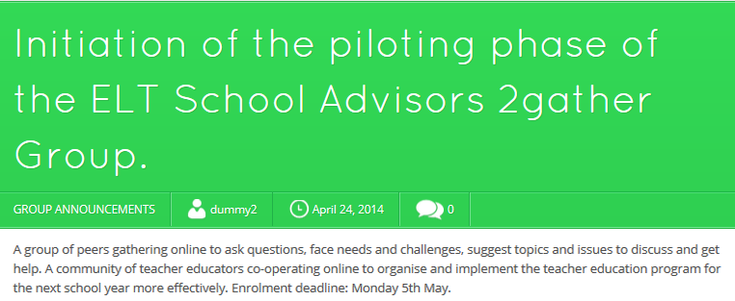

- How can I join the forum discussion?
Go to the top right corner of the page with the green tiles. Click the “Forum” tile.
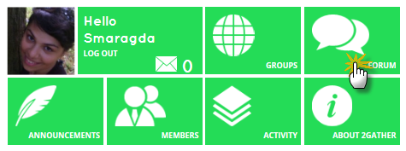

Click your group’s forum.
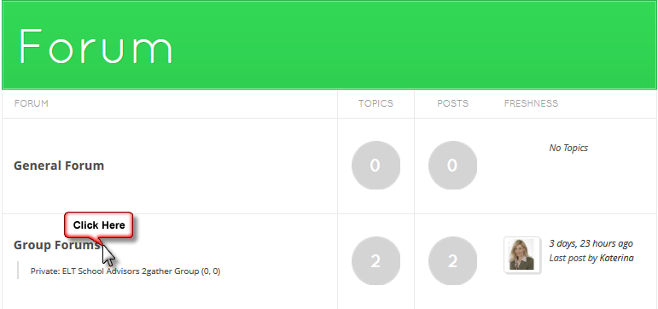

- How can I respond to a forum topic?
When on your group’s forum, click the topic you wish to respond to. Insert your answer and click “submit”.
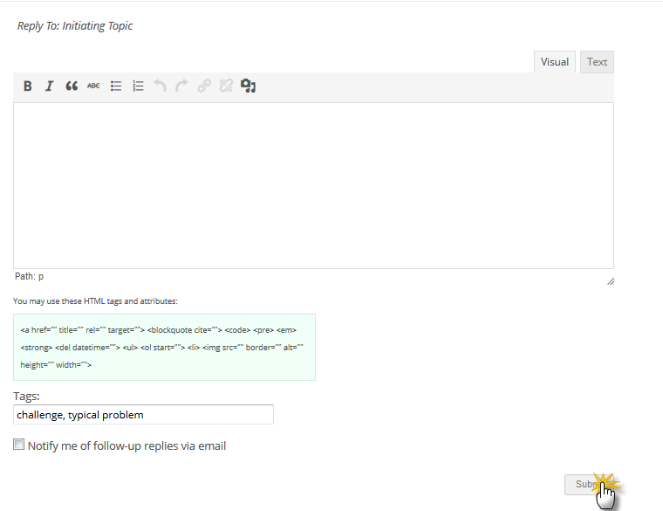

- How can I initiate a forum topic?
From “Group Forums” go to “Create New Topic” and enter the title and content of your topic. Don’t forget to insert a topic tag. Then click “Submit”.

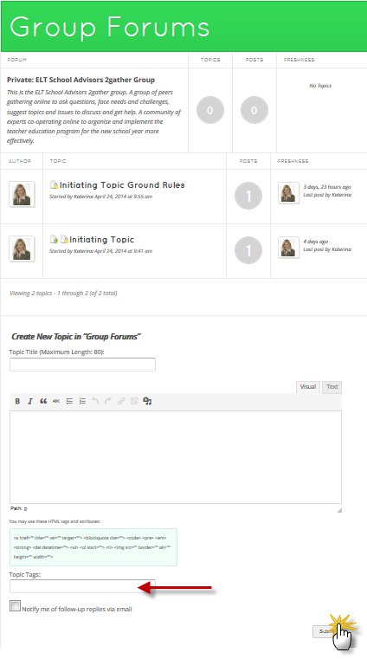

- What is a topic tag?
It is a keyword associated with the content of your topic/response. It must be necessarily filled in every time you submit a topic/response for classification purposes.

- What does it mean to subscribe to a topic? How can I do it?
It means to be notified every time a new response is posted. Click the topic you wish to subscribe to and click the “subscribe” green button.
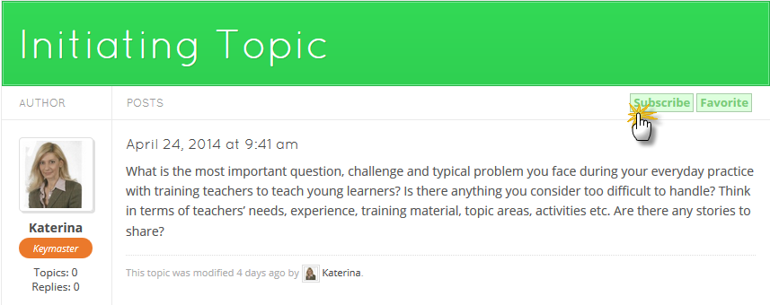

- How can I attach a file/image/video to my posts/messages?
From “Group Forums” go to “Create New Topic” and enter the title and content of your topic. Below the text editor press the button “Αναζήτηση”. From the window that will pop up chose your file. Then click “Submit”.

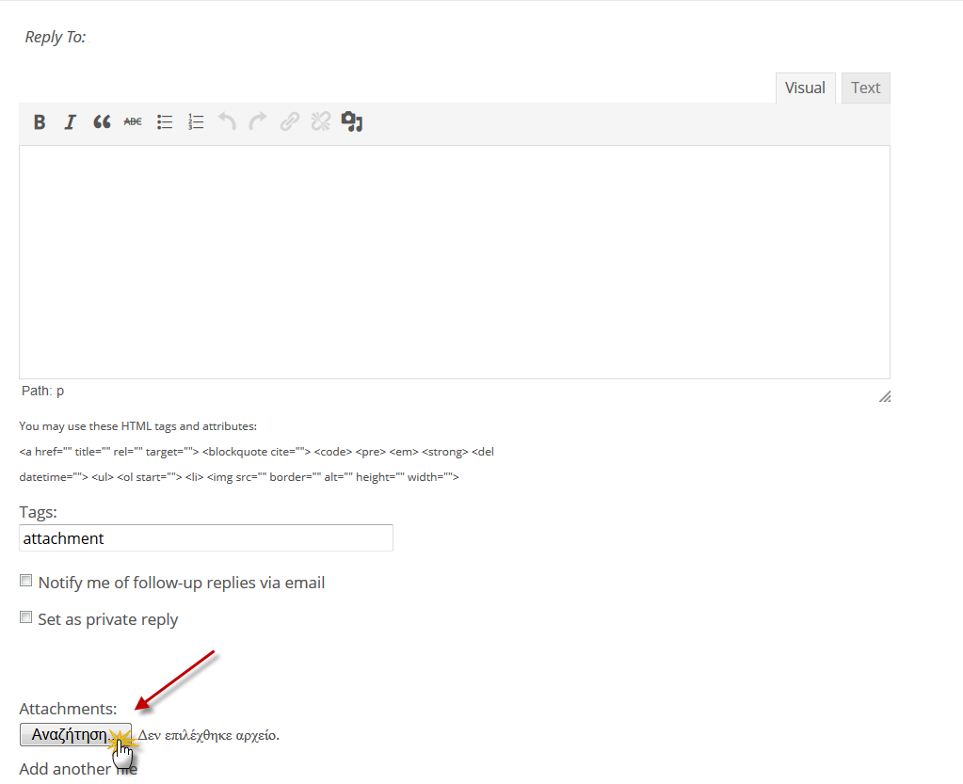

- How can I create a link for my colleagues?
When writing a post, you have to select the desired text and click the link icon situated in the toolbar above the editor.
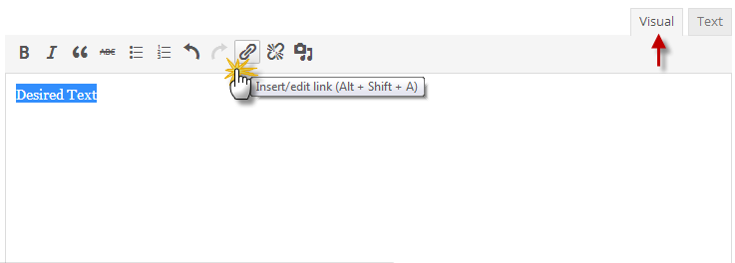

Enter the destination url and click “Add Link”.
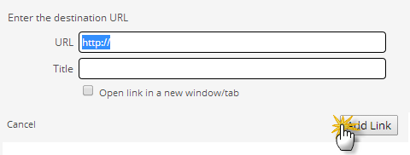

- What is the difference between a forum topic and a discussion thread?
A discussion thread is the conversation that results from the topic.

- What is a pop-up notification?
In is an orange pop up message that appears in the bottom right corner every time there is something new to be notified of. You should just click it.
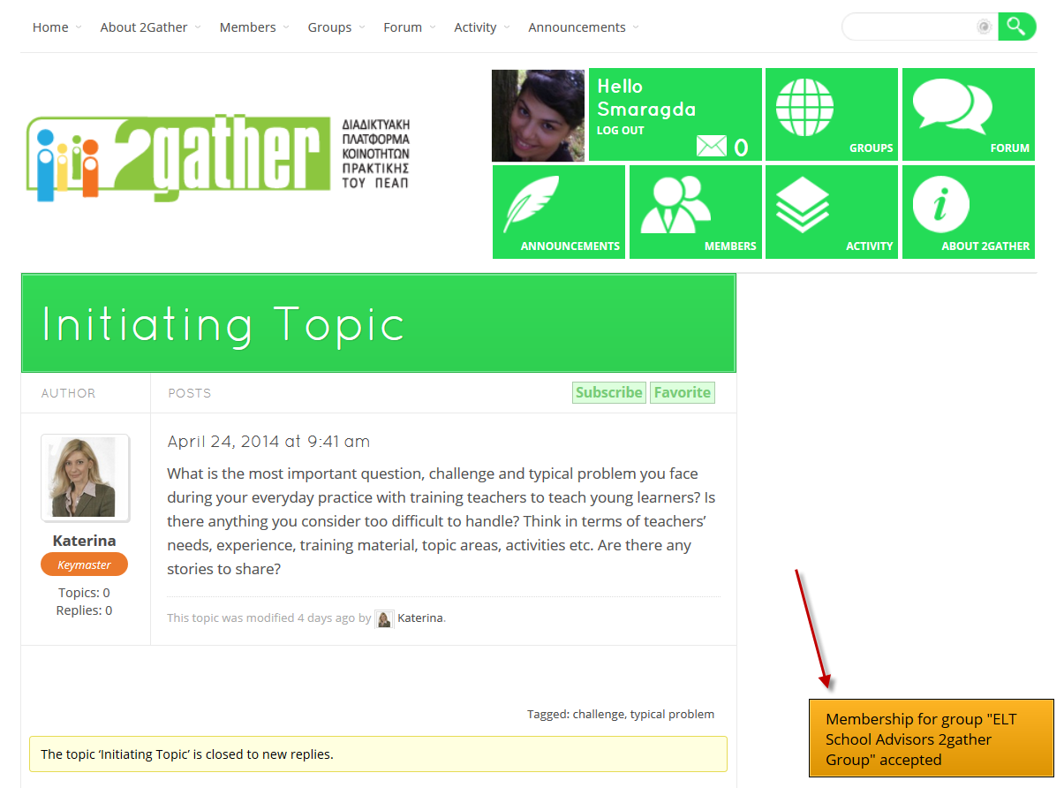

- How can I make friends/friend requests?
Go to the top right corner of the page with the green tiles. Click the “Members” tile.
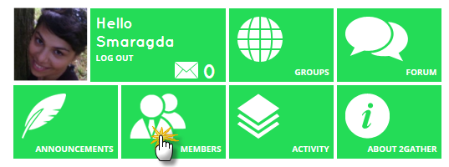

You will be presented with a list of members. Click the “Add Friend” button.
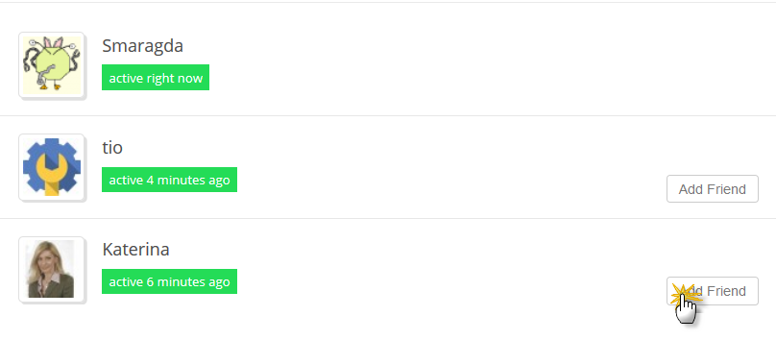

- How can I accept/reject friend requests?
As soon as you log in, in the lower right corner of the page, you will see an orange pop-up notification.

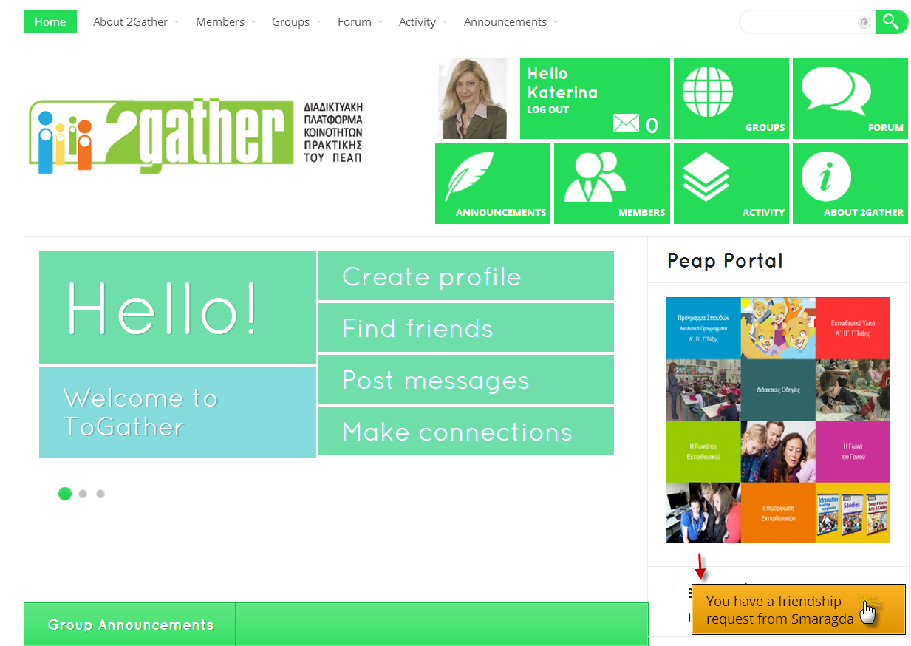

Click on it and from there you will be presented with the user requesting your friendship. Just click the “accept” or “reject” buttons.
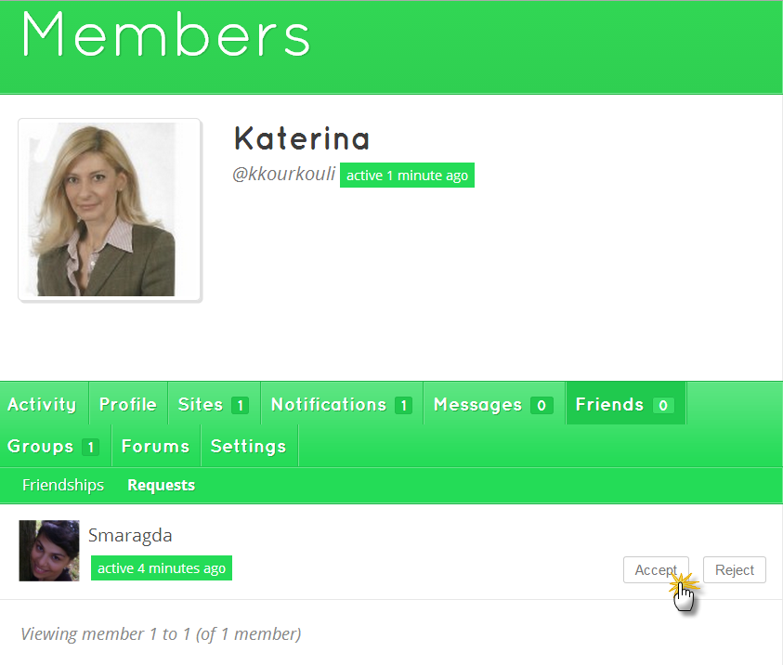

- How can I send a message?
Click the “Members” green tile. Select the member you wish to send a message.
From there click the “Public Message” if you want it to be seen by everyone or the “Private Message” to be seen only by the selected member.
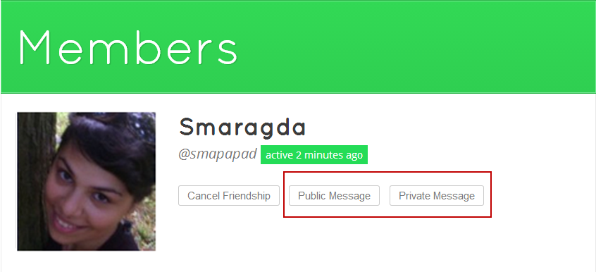

- How can I read a message?
When you log in, click the orange pop up notification in the lower right corner.
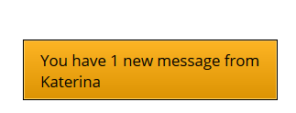

- How can I reply to a message?
After reading the message, type your text and click the reply button.

- How can I keep/send a reflective journal?
When on your group’s forum, click the topic that asks for your reflective journal. Then attach your document like you do in step 14. Then check the box that says “Set as private reply". Then click “submit”.

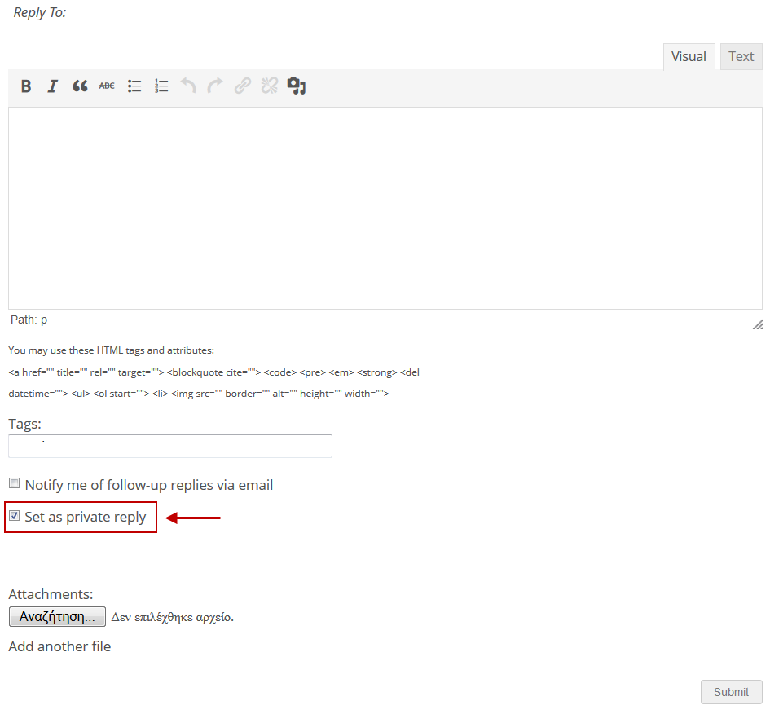

- How can I log out?
Go to the top right corner of the page with the green tiles. Click the “Log Out” green tile.
